AP Calc WS#6 Continuity Name: _____________

Continuous means the graph have no "breaks", "gaps" or "holes".

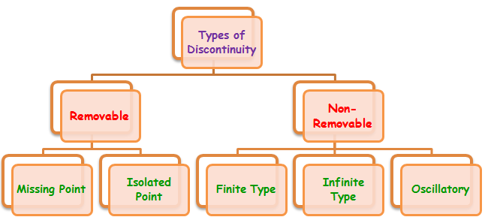

Extra: Sketch the graphs of each of the five types

1. The continuity test: A function y = f(x) is continuous at x = c if and only if it meets all three of the following conditions

1. f(c) exists (f is defined at c)

2 $\lim_{x→c}f(x)$ exists (f has a limit as x → c)

3 $\lim_{x→c}f(x)=f(c)$ (the limit equals the function value)

To test for end points use one side limit.

Use the test to see check for the continuity of the following functions

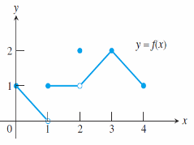At x = 0

At x = 1

At x = 2

At x = 3

At x = 4

Conclusion: The function is continuous on [0, 4] except at

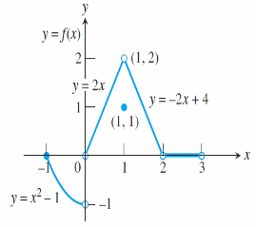

2. Sketch a possible graph for a function f that has the stated properties.

* f (1) has a nonremovable discontinuity.
* f (2) exists, $\lim_{x→2^{+}}{f(x)}=f(2)$, but $\lim_{x→2^{-}}{f\left(x\right)=DNE}$
* f (3) exists but $\lim_{x→3}{f(x)}$) does not.
* f (4) exists, $\lim_{x→4^{}}{f(x)}$ exists, but f is not continuous at x = 4.

3 Using graphing to show the continuity of the following functions. Indicate the point of discontinuity if any

a. y = $\frac{1}{x}$ b. y = $\frac{x^{2}+5}{x-2}$ c. y = | x| d. y = sin (x) (radian)

e. y = $\frac{x^{2}+x-6}{x^{2}-4}$ f. y = $\sqrt{xcosx}$ g. y = tan(x) h. y =

i. y = j y =

4. Continuity versus Having a limit

If a function is *continuous* at a point → It is having a *limit* at this point

If a function is having a *limit* at a point → It may or *may not continuous* at this point

Give example by graph and algebra

continuous and limit limit but discontinuity

5. Determine the limit and continuity of the following at the given point (feel free to online)

6. Composite of Continuous Functions:

If f is continuous at c and g is continuous at f (c), then the composite g f is continuous at c.

Show that $y=∣\frac{xsin(x)}{x^{2}+2}∣$ is continuous

Let f(x) = g(x) =

Therefore f(g(x)) =

Now you do: Using the composite of continuous to show the following functions are continuous

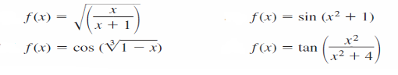

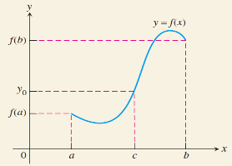7. The Intermediate Value Theorem for Continuous Functions:

*A function y = f(x) that is continuous on a a closed interval [a, b] takes on every value between f(a) and f(b).*

In other words, if yo is between f(a) and f(b) then yo = f(c) for some c in [a, b]

(When the function is continuous, it has no gap)

Ex: Is any real number exactly 1 less than its cube? aka Prove that x = x3 – 1 has solution

We answer this question by applying the Intermediate Value Theorem (IVT) to check whether the function f(x) = x3 – x – 1 is continuous when the function has its zero value.

Here is the graph of the function = Polynomial

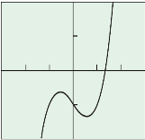

We see the function has its zero between x = 1 and x = 2

We say: *A function y = f(x) that is continuous on a a closed interval*

*[__, __] takes on every value between f(__ ) and f(__ ).*

In other words, **if** zero (0) is between f(__) and f(___) **then**

0 = f(c) for some c in [___, _____]

Use graphing calculator to find value of c = ? ____________ (3 decimal)

Now you do:.

Is any real number exactly 1 less than its fourth power? Your writing should include the IVT’s wording

Give any such values accurate to 3 decimal places.

Is any real number exactly 2 more than its cube? Give any such values accurate to 3 decimal places

Test on Limit after this